Fixing the Holes in Holes:
On Optimizing and Scaling the Operation of Hot Hole Spin-Qubits

As qubits from across various physical platforms are plotted on a speed-coherence map, a seemingly systematic pattern emerges: increased coherence is only achieved at the cost of operation speed. Commonly discussed, yet rarely quantified, this speed-coherence trade-off might pose a fundamental limit on qubit performance [1]. Particularly systems using strong spin-orbit interaction (SOI) for fast qubit control via electric dipole spin resonance (EDSR) may be more vulnerable to charge noise coupling to the qubit through the same channel as the driving field, further increasing penalties on coherence. This complication has given hole spins a certain notoriety, underlining the importance of better understanding this driving mechanism to design a compromise-free functional dependence between speed and coherence.

In our work [2], we demonstrate a hole spin qubit in a Ge/Si core/shell nanowire that achieves a coherence sweet spot at maximal driving speeds by tuning a local electric field. This approach not only triples the qubit speed but also quadruples the Hahn-echo coherence time, significantly boosting the Q-factor by more than an order of magnitude. Translating this principle to similar spin qubit systems could fundamentally alter the landscape of quantum computing, finally allowing us to fully exploit the high scalability and simplified device architecture hole spins offer, without the previously feared drawbacks, such as increased coupling to charge noise.
Additionally, we showcase the feasibility of conditional two-qubit (2Q) operations at the elevated temperature of 1.5 K, providing an underlying mechanism of entangling two-qubit logic gates [3].

These breakthroughs open up new possibilities for designing scalable, high-performance quantum processors based on hole spins, overcoming key limitations that have long impacted their development.

References:

[1] MJ Carballido, “A Perspective: Navigating the Speed-Coherence Trade-Off”,
in preparation (2024)

[2] MJ Carballido et al., “Compromise-Free Scaling of Qubit Speed and Coherence”, arxiv.2402.07313, (2024)

[3] MJ Carballido et al., “Conditional Operations of Hot Hole Spin Qubits”,
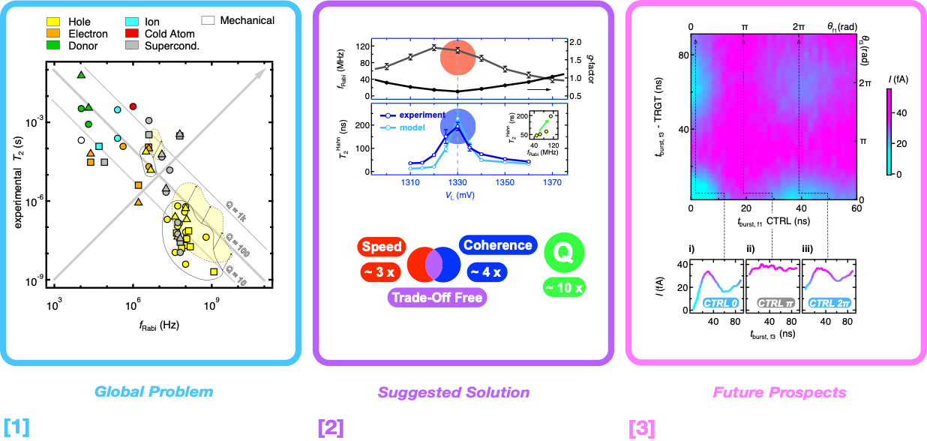
in preparation (2024)

